**Restaurant Employee Management**

*(Chain of Restaurant)*

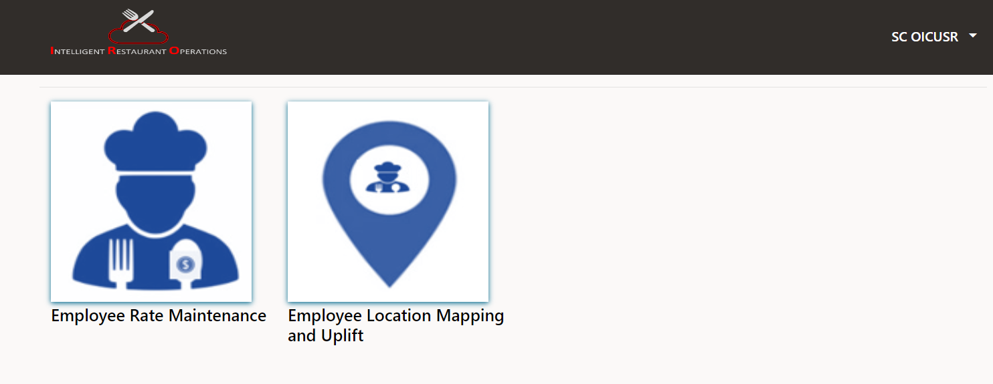

(The below screen is from Blinker Side)

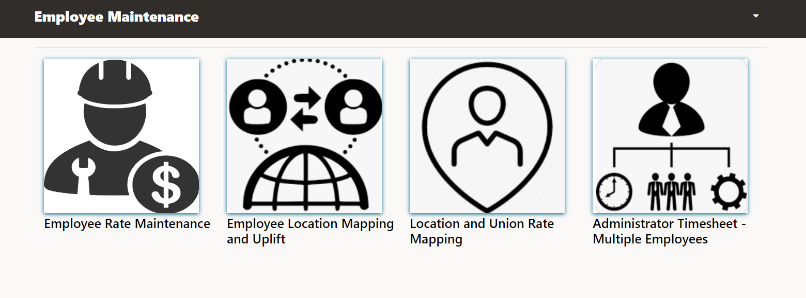

Our comprehensive Employee Management System for restaurants empowers managers to efficiently handle all aspects of employee administration. This includes maintaining detailed records of employee roles and their corresponding job rates within the restaurant. Managers can effortlessly map employee locations and create precise timesheets, incorporating location-specific and union-specific rates.

The system seamlessly integrates with SaaS Fusion to create Accounts Receivable (AR) invoices from timesheets, consolidating all relevant information onto a single screen. This user-friendly interface allows managers to easily review, manage, and respond to employee data, promoting streamlined operations and improved organizational oversight.

To overcome the limitation in SaaS Fusion where multiple jobs cannot be assigned to a single employee, we have developed a versatile VBCS (Visual Builder Cloud Service) screen. This enhanced interface allows managers to assign multiple jobs to employees and manage job-specific rates efficiently. Additionally, managers can adjust these rates dynamically based on predefined rate ratios. This integrated solution, involving AOR (Accounts Receivable), managers, and employees, ensures that all job assignments and rate adjustments are handled seamlessly, thereby enhancing overall employee management and operational efficiency.

# Employee Rate Maintenance

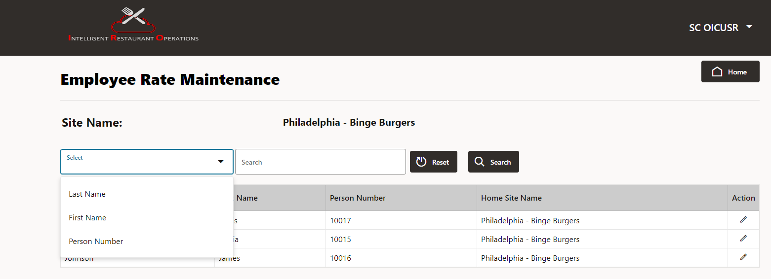

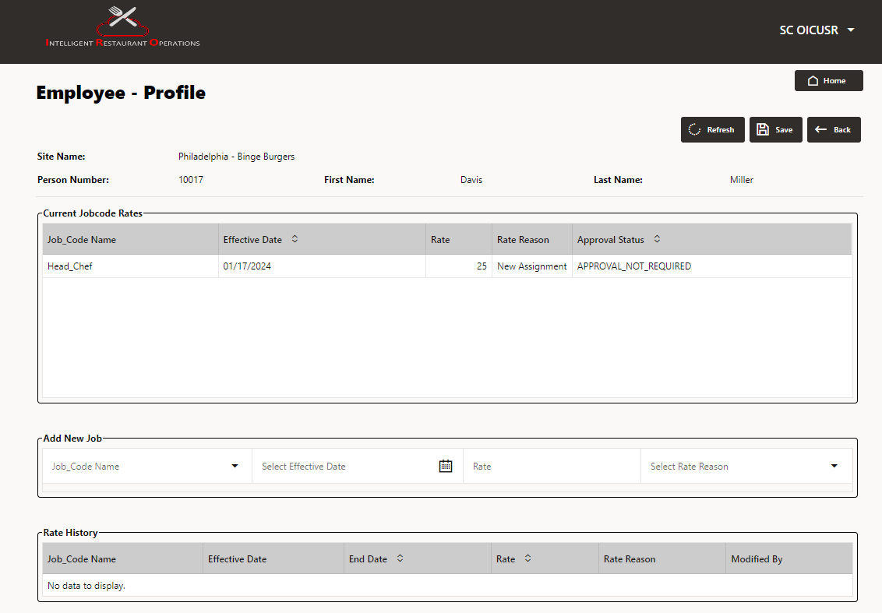

* The primary function of our employee rate maintenance system is to facilitate rate changes for restaurant employees by allowing managers to search specific profile and details of the employee on this screen.
* This screen includes an "**Action**" option for editing profiles and specific job rates, triggering alerts and approval requests when new rates are added.
* Once profiles are updated and saved, the requests are submitted to the Accounts Receivable (AOR) system, with their status displayed in a table, changing from "Sent for Approval" to "Approved" upon AOR processing.
* Additionally, managers can add new jobs for employees, with the system displaying a complete history of each employee's job assignments and rates in **Rate History** table, ensuring accurate rate management and comprehensive tracking of employee roles and rates.

# Employee Location Mapping

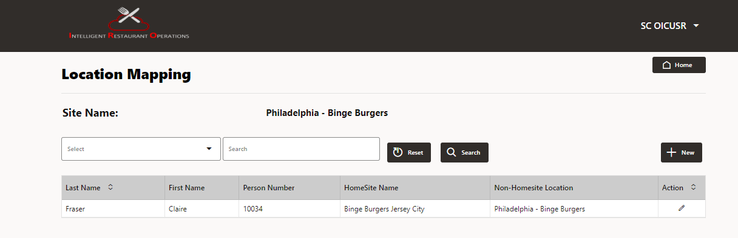

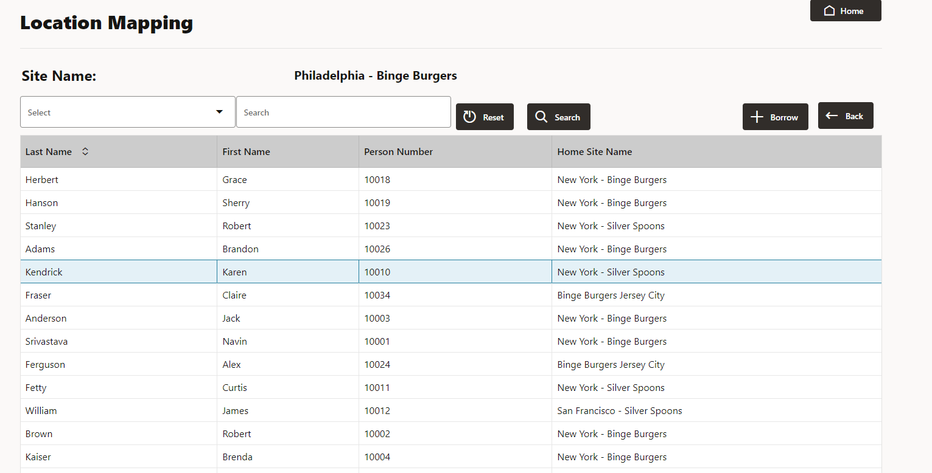

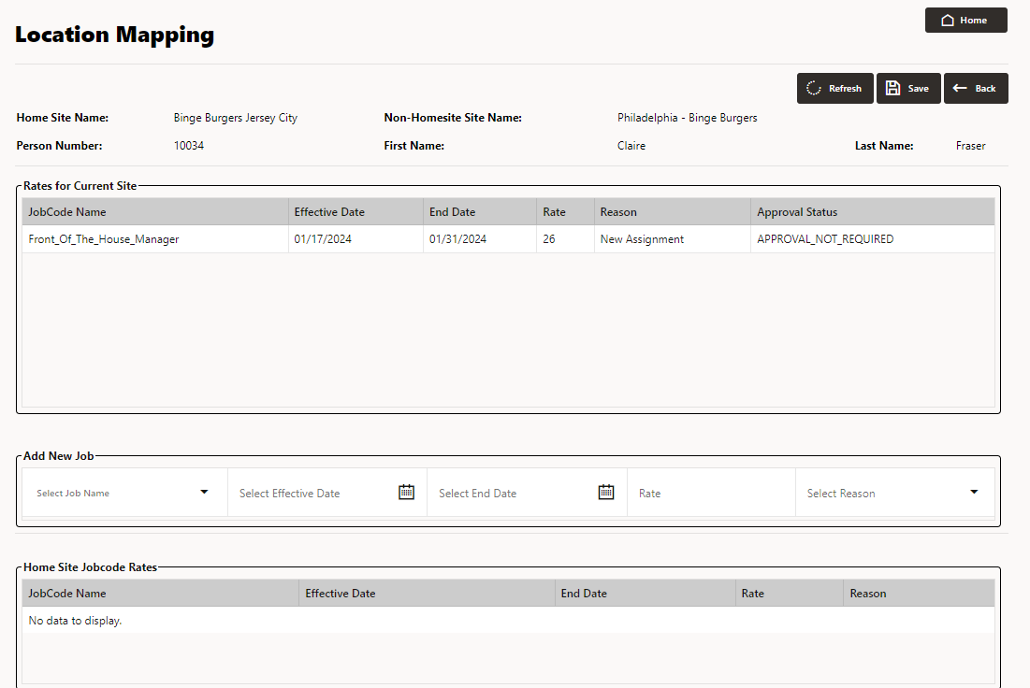

* Location mapping feature empowers managers to borrow employees from other restaurants, enhancing flexibility in workforce management.
* Upon selecting "New," a list of available employees is displayed, enabling managers to choose the desired candidate and proceed with the borrowing process.
* Managers can choose the desired candidate and proceed by clicking "Borrow."
* This action transitions to the next screen, where managers can add new job assignments for the employee and review their job history.
* Once the necessary information is added and saved, it promptly updates the system's database, ensuring real-time accuracy.
* This functionality facilitates the seamless hiring of the borrowed employee at the new location for a specified duration.

# Location And Union Rate

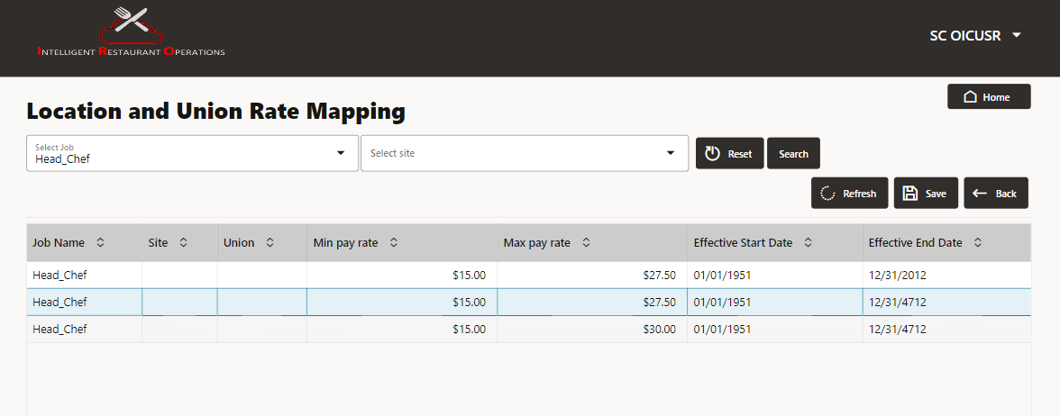

# Administrator Timesheet -Multiple Employee

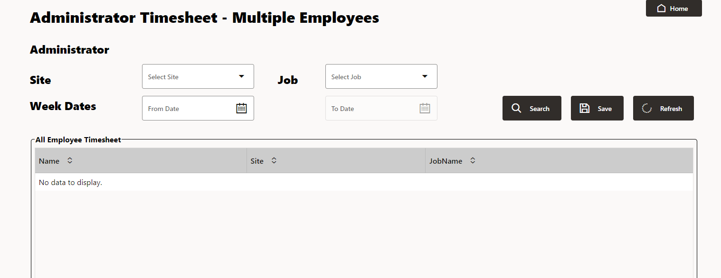

# Restaurant Invoice App

